A visit to Spheresville. October 10th 2143
By Adam Green
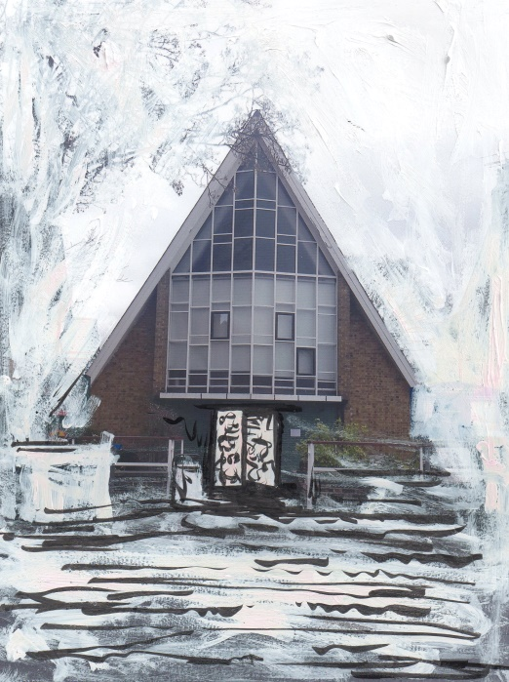
The Apocalypse Club, Spheresville. 2143
I am standing outside the doors of the Apocalypse Club and I am waiting for Burnt Toast Geometry. He’s late. To pass the time I study the wooden doors in more detail. They are beautifully carved depicting scenes that I do not really know the meanings of.
Stone town, Zanzibar is famous for its ornate carved wooden doors. Each door is individually tailored to the owner of the property. For example a merchant who made their money in fishing would have patterns that represent waves or maybe the scales of a giant marlin.
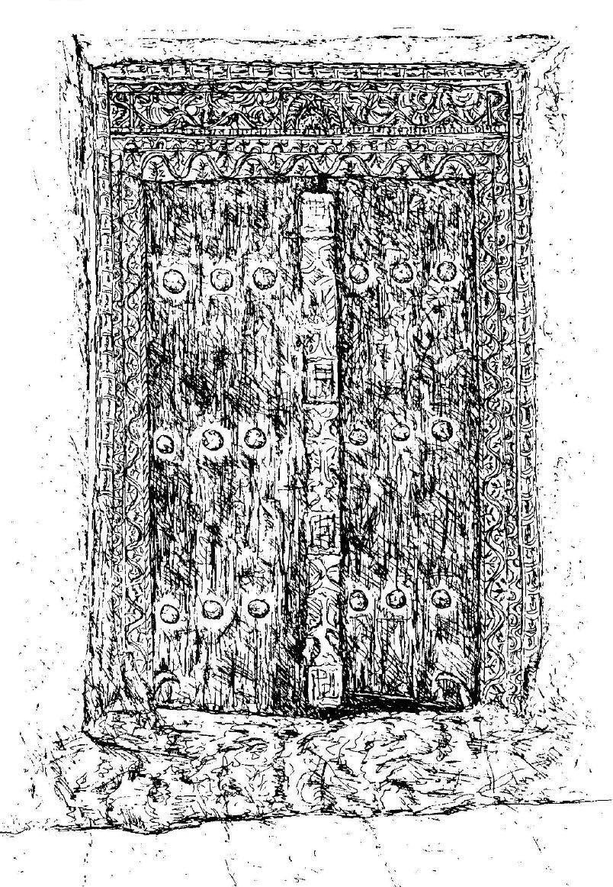
Drawing of Zanzibar Door by Damien Green. 2003
One of the doors slowly creaks open. Burnt emerges wearing a long chequered coat and sunglasses.
“Sorry I’m late” says Burnt. “I had a gig at the club last night”
“That’s OK” I say. “What was it?”
“I did a performance” he says. “It was called 100 drawings/100 minutes. I sat and drew for nearly two hours and pinned up the drawings as I went. It was interesting. There wasn’t a big crowd and people drifted in and out during the night.”
“That’s really cool” I replied. “Does it pay well?”
“No, not really but I can sell artefacts from the performance that will bring in some sphere dollars.
In2003 Marcus Coates was artist in residence at a tower block in Liverpool. He performed a shamanic ritual to some of the residents in order to find a positive outcome to a possible relocation of the residents. He documented this event with photographs and a video which were then able to be sold through galleries.
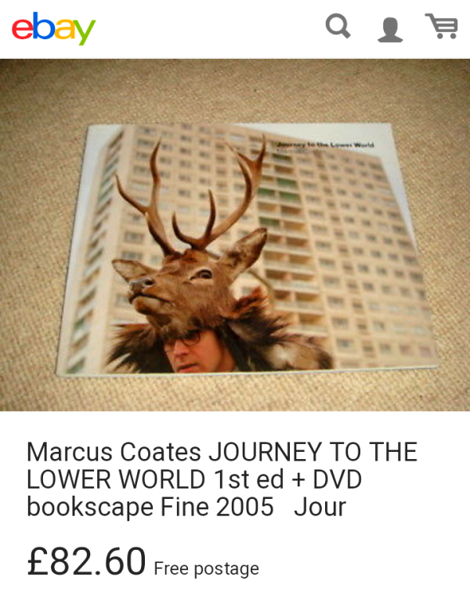
EBay screen shot of Marcus Coates book, Journey to the Lower world.
“There will be a souvenir book, a DVD, maybe a novelty mug.” Burnt laughed. “I like the idea of generating a mythology around this event.”
In 1993 Tracey Emin and Sarah Lucas opened up a shop in Bethnal Green Road. The shop sold works by the two of them including t-shirts and ashtrays with Damien Hurst’s face stuck to the bottom.
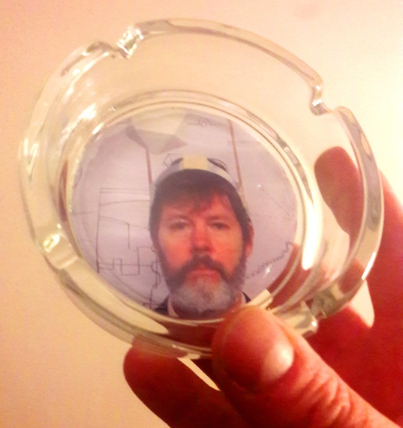
100drawings/100minutes ashtray
“Exciting” I say. “Count me in for a DVD when it comes out”
I tell Burnt I was studying the imagery on the wooden doors before he appeared and asked if he knew what they represented.
“Ah yes” he says. “It is the creation story of Spheresville set out in a series of reliefs. I don’t know who carved them as they were here long before me.”
“This one shows the arrival of the sphere above Chanctonbury Ring and the people flocking to see it.
This one shows the madness that overtook the world with the arrival of it.
This one shows a family setting up a camp near the base of the sphere only to be arrested by police.
I think this one is about what might be inside the sphere.” He points to a lower relief. “Obviously we don’t know so I guess we can make up whatever stories we want.”
“Fascinating” I say. “It makes me think of the Dogons”.
“Who are they?” asks Burnt.
The Dogon are from Mali, Africa. Their creation stories are believed to go back thousands of years and some claim that they may be descended from the ancient Egyptians. What really sets the Dogon apart is that they believe in an “egg of the world” out in space which is now known to modern astronomers as “Sirius B.” How astrological maps depicting this star exist on ancient Dogon artefacts is baffling since the star was only discovered in 1970.
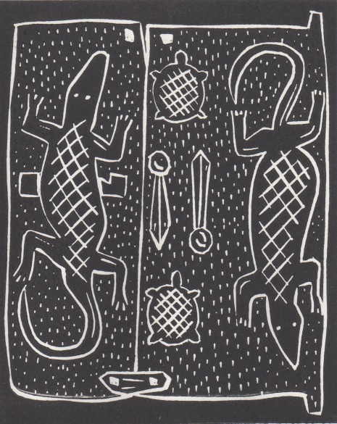
Dogon window shutter. Lino cut by Damien Green. 2018
We walk away from the club. Burnt has offered to show me around a little.
It’s an unusual town, hard to describe. It makes me think of Montmartre in the 1900s but with a sense of dystopia slicing through it.
In 1900 Picasso arrived in Paris to see his painting on display at the world fair. It changed everything and was the birth of cross pollinations of art. Music, painting and dance coming together in performances like Cocteau’s Parade.
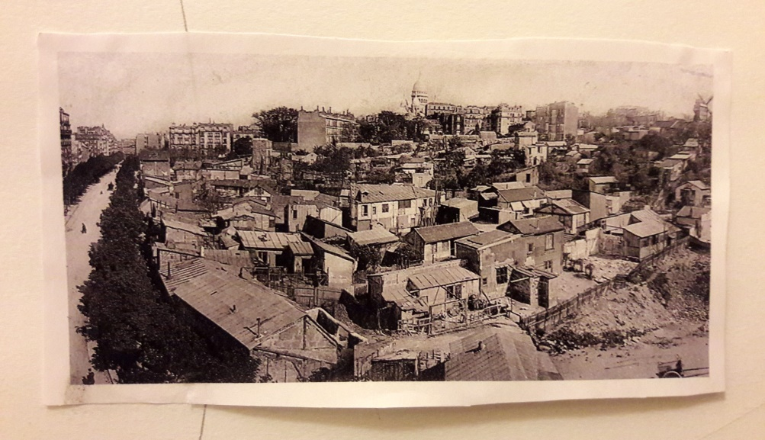
Montmatre, circa 1900. Photographer unknown.
In 1983 Ridley Scott directed the film Blade Runner. The film is set in a dystopian future Los Angeles of 2019, in which synthetic humans known as replicants are bio-engineered by the powerful Tyrell Corporation to work on off world colonies.
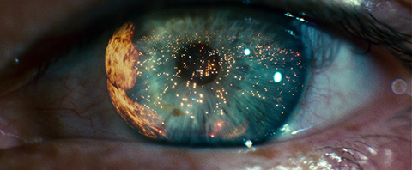
Film still from ‘Bladerunner’. Copyright Warner Bros Pictures
We begin to walk. Its 12pm on an autumn day. The light is subdued but there is blue sky. It’s very quiet on the streets. The people that I do see seem to eye me suspiciously. I mentioned this to Burnt. He doesn’t look up but says “They probably think you are working for THEM.”
“Them?” I ask.
“Spheretec” He replies.
Starting off as a small technology company tasked with investigating the Sphere, Spheretec has grown into an enormous multinational corporation with far reaching powers controlling the media and security forces.
People don’t watch television” he says. “There’s too much propaganda. That’s why people come to the theatres and clubs and watch daft things like people drawing. It’s because it’s real.
“I understand” I say. I guess it’s also why the town comes to life at night?”
“Yes” he says smiling.
We continue to wind our way down the road.
I look up. In the distance I see it, silently spinning as it has done for the last 150 years surrounded by a giant fence.
Spheresville grew up at the base of what was once commonly known as Chanctonbury Ring.
Chanctonbury Ring is a prehistoric hill fort atop Chanctonbury Hill on the South Downs with over 2000 years of recorded occupation.
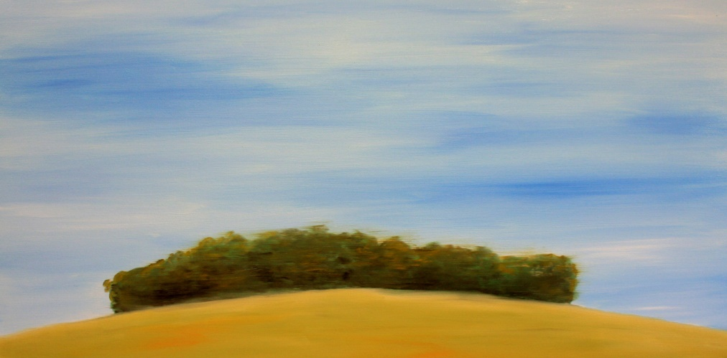
Chanctonbury Ring. Oil on canvas. Damien Green. 2018
Even though I know about the sphere and have read about it and seen it on TV and in the media, this is the first time I have been to Spheresville and actually seen it.
It feels very much like the first time I visited Cairo and saw the Great Pyramid. But unlike the pyramid, we know virtually nothing about the sphere. This leaves you with a very uneasy feeling as you gaze at it.
I ask Burnt what he thinks of the Sphere. He looks up peering through his sunglasses.
“What do I think?” he says…” I haven’t a bloody clue” he laughs…
I don’t think he’s telling the truth, but I don’t push it.
“I’ve lived in Spheresville my entire life. For me it just is what it is. It’s there spinning away like it always has. You know, I do have my theories but hey, I keep those to myself. I don’t want to get arrested! And besides the tourists love it and I can make a few dollars from that.
We arrive at a coffee shop.
“I need a coffee” he says. “Want one”?
“Sure”
We sit outside. It’s lovely and fresh but not cold at all. Maybe next month it will turn to thicker jumpers and hats and gloves but for now we can enjoy the fresh air.
“So what’s your next performance?” I ask.
“Well” he says. “My brother and I are in a band and we are getting ready for our first big gig. We’ve done an album and everything. It’s epic!”
What are you called?” I ask.
“Shunt Limit” He says with conviction “and the album is called Spherical Spaghetti”
In 2006 Jamie Shovelin fooled the art world with his fictional band Lustfaust.
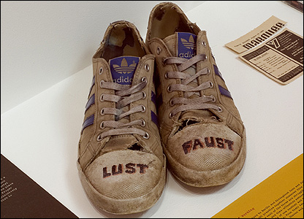
Lustfaust shoes. Copyright Jamie Shovelin
“We’ll be performing it at the Apocalypse club next week. You should come.”
“Thanks” I say. “I might just take you up on that”
Please follow link to video performance of Essay.
https://www.youtube.com/watch?v=7K2QSz-j_NM&feature=youtu.be

Biography and references

Alys, Francis (2005) Seven Walks, London 2004-5. Published by Artangel
Baume, Sara (2017) A line made by walking. Windmill Books.
BladeRunner (1982) The Ladd Company, The Shaw Brothers, Warner Bros
Keiller, Patrick. (1994) London. D. Patrick Keiller. P.Keith Griffiths
Keiller, Patrick (1997) Robinson in Space. D. Patrick Keiller. P. Keith Griffiths
Keiller, Patrick (2010) Robinson in ruins. D Patrick Keiller
Mwalim A, Mwalim (1998) Doors of Zanzibar. HSP Publications
O’Sullivan, Simon (2018) Fictioning the landscape. Journal of Aesthetics and Phenomenology, 5:1, 53-65, DOI: 10.1080/20539320.2018.1460114
Peters, Arthur King (1987) Jean Cocteau and his world. Thames and Hudson
Roe, Sue (2014) In Montmarte Penguin Books
Roe, Sue (2018) In Montparnasse Pengiun Books
Shovelin, Jamie. (2007) A dream Deferred. Haunch of Venison publications.
Shovelin, Jamie. (2009) The evening redness in the west. Haunch of Venison publications.
Williams, Bedwyr. (2016) The Gulch. The Barbican.
https://web.archive.org/web/20070918114155/http://www.lustfaust.com/ Accessed 5/12/2018
http://www.sussexarch.org.uk/saaf/chanctonbury.html Accessed 5/12/2018
https://www.britannica.com/topic/Amma Accessed 9/12/18
https://www.theguardian.com/artanddesign/2013/aug/12/tracey-emin-sarah-lucas-shop
Accessed 9/12/18
http://www.katemacgarry.com/artists/marcus-coates/ Accessed 10/12/18
https://www.youtube.com/watch?v=9SVJ91Mq5g0 Accessed 28/12/18

