A Nesting of Fictions.
Adam Green
Time Codex 16.07.2019.8.23
Location-Bath Central Bus Station
I arrive at the bus station with plenty of time to spare. I checked online the previous evening to see what time the buses depart to Bath Spa University. Every fifteen minutes it stated.
Standing in the bus station there are about 16 gateways. Each one has its own bus that stops there. The bus I am looking for is the U5 and its gateway is located right at the end of the building, gate number 15. There is also a digital table listing impending departures. No U5 as of yet. Fifteen minutes go by. There is still no bus. There is a young woman who seems to be looking for the same bus. She gets up every now and then and goes and asks a member of staff if she is in the right place. I can’t really hear what she says but talking to the man in uniform seems to calm her down and so this in turn calms me also. I still don’t know when the bus is due. It should be soon.
Time Codex 16.07.2019.9.00
There is still no sign of the U5 on the big digital display. Just then a tall man walks into the building. Dressed in black and looking quite arty. He’s wearing sunglasses but I am convinced it is Simon O’Sullivan. I keep looking out the corner of my eye. I’m sure it is. I’ve never met Simon O’Sullivan and I have only seen videos of him during his performances with Plastique Fantastique.
Plastique Fantastique is collaboration between artists Simon O’ Sullivan, David Burrows, Alex Marzeta and Vanessa Page exploring mythopoetic fiction through performance, installation, comics, text, shrines and assemblages.
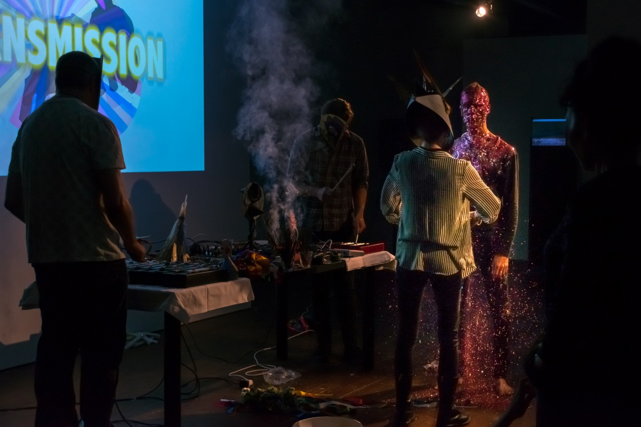
Plastique Fantastique. Image courtesy IMT Gallery
The man wanders over to gate 15 and glances down at the piece of paper attached to the wall. He then turns and exits the building and heads straight for Café Nero across the road. Once he is gone I casually walk over the thing he was looking at. Ah .a timetable but more importantly an up to date timetable. It even states ‘an up to date timetable’ the next bus is at 9.25. I must have looked at the wrong website last night. So I had just missed the 8.20 when I arrived and now the next one is due at 9.25. My nervous anxiety increases. Check in for the Digital Ecologies 2, Fiction Machines symposium is 9-9.45. I really hate being late. I generally find it impossible TO be late. Could this be the first time?
I have 20 minutes. I head to Café Nero. The possible Simon O’Sullivan has just ordered a black coffee. I nearly ask him but chicken out. He leaves and I order a flat white. It is made by the trainee Barrister and takes flipping ages. Even though I have 15 minutes it is still really stressful. And when I do get handed it, it is 90% foam but I’m too anxious to say anything and I don’t want to upset the trainee. I wouldn’t want to do that job. So I leave hurriedly and head back. No need to leave hurriedly at all. I’ve still got 10 minutes.
Time Codex 16.07.2019.9.15
The bus finally pulls into its designated platform. Lots of people get off but no one is allowed on. I’m standing next to possible Simon O’Sullivan. Now is my chance. It’s only a few minutes of awkwardness if he isn’t but also if he is it’s only a few minutes before he realises I don’t have a clue what he’s talking about most of the time. As the saying goes. “Better to be thought a fool than to speak and be known as one”.
Time Codex 16.07.2019.9.20
“Excuse me. Are you Simon O’Sullivan?” I ask nervously.
The man looks at me or down on me as he’s quite tall. If I was to question myself on why this isn’t Simon O’Sullivan I would have told myself he is too tall after viewing Simon O’Sullivan on You tube.
“Am I Simon O’Sullivan?” the man says as he takes off his sunglasses. “No I’m not” he says.
What a fool I have been I think as I shrivel up into an amoeba.
“Oh, sorry” I say.
“But I do know Simon O’Sullivan” he says.
Wow, OK, this is salvageable. He’s not just a random man getting a bus and I’ve asked a stupid question. He is in fact going to the symposium. His name is Dale and he currently doing a PHD in curating at Edinburgh. He says he has worked with Simon on various things including the Plastique Fantastique work.
Just then, the doors to our bus platform open and we are allowed on. A bit of small talk in the queue and Dale gets on first. He goes upstairs. I get my return ticket and head upstairs also. I hate upstairs on buses. They make me really nauseous. But I go up as I think it would be weird and a bit unsocial to not. I sit opposite Dale and he tells me a bit about himself and why he is here. I ask about his PHD and if he has a good supervisor. I know this is a good question because my fiancé is doing one and her brother is also doing a PHD. Her supervisor is fantastic, his is useless. It’s really important. Dale says his is great and mentions his supervisor is into Neo Medievalism. I have no idea what this is. He tells me and I’m still clueless. I don’t know how to reply so I go quiet and take out my note book and jot down his name. The rest of the bus journey is in silence. This is a good thing as I can concentrate on not being bus sick.
Time Codex 16.07.2019.9.54
We arrive at the university campus 9 minutes after registration ended. As we enter the main reception or Atrium as it is known we are greeted by a lady who asks for our names and then scours the table of badges to find ours. There are still quite a few badges left. I feel less ashamed of my lateness.
Once given our badges we are pointed to a staircase in the corner and told to go up one flight of stairs to room 107/108. Before I do I glance around the Atrium and see a giant digital screen. On it is displayed Rod Dickinson’s Fear Filter artwork. On the bus I had told Dale about Rod Dickinson and his Fear Filter App. I also mentioned I had visited his studios in South London 25 years ago.
Fear Filter is a digital photo artwork by Rod Dickinson. It comprises of a digital photo stream of user generated images which are displayed on the media wall, and a mobile phone photo filters app for android/IOS. The Fear Filter app includes filters than can be applied to photos. The app abstracts the photos using data from MI5 and the UK security service. The greater the UK Terror Threat the more abstract the photo becomes.
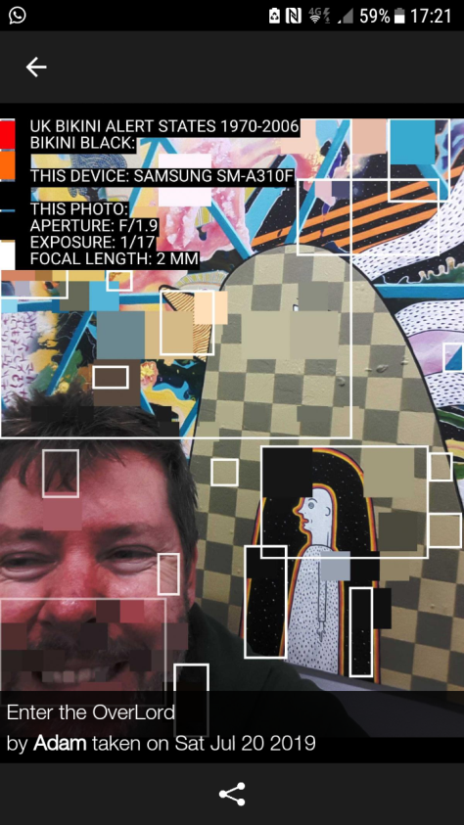
Fear Filter photos produced by the author

“ooh” he said.
We both climbed the stairs with our badges proudly displayed. I felt like I was at a corporate function. I think the campus building added to that feeling as it was quite clinical and office like.
As we reached the landing Simon O’Sullivan came straight towards us and greeted Dale. Maybe I should’ve hung around to introduce myself but I didn’t want to intrude so I headed off to the gender neutral toilets.
Time Codex 16.07.2019.10.06
As I entered to conference room I went straight to the free coffee station. Lots of people were still milling about so I was feeling more relaxed. There were lots of seats available too. I poured myself a coffee, or should I say I had to get help to pour the coffee as I couldn’t work the big coffee jugs. They needed to be unscrewed an exact amount in order to release the liquid. I have a vague memory of unscrewing one too much.
I found a seat. I hadn’t seen Dale and even if I had I wouldn’t have sat next to him. It would be nothing personal at all. I just couldn’t tell if he thought I was a bit annoying so if it was the other way round I would have thought “Oh no, can he stop trying to be my friend”
Time Codex 16.07.2019.10.16
Charlie Tweed, organiser of the symposium gives an introduction to the day. He starts by talking about ‘Null Island’. Null Island is a fictional island that is located at the centre of the Earth. From this fictional land all our longitudes and latitudes and GPS are all coordinated. This piece of ‘fiction’ is needed in order for our computers to work. It is where the equator meets the meridian.
‘The point where the lines meet, 0* North, 0* East, baffles the machines. Computers need a piece of land there on which to ground their calculations. So we feed them a fiction, throw an island out into the ocean, tell the machines a story about the land at the origin of the world; and in return they run the numbers for our GPS, guiding us home safely at night, leading us to shoals of fish to eat. From this unreal centre, the machines can tag our photos to map our memories and images onto the material world. Whenever we perform one of these actions we pass through a fiction.
Through the stories and numbers of Null Island, this tiny piece of land without a sovereign, we see a fiction deployed as a method.’ (2017 p.6-8)

What do we mean when we think of fiction? If you were to have asked me before I began my Masters I would have said something like
“Fiction is telling a story, a book, a film, a lie.”
In the dictionary the definition of fiction is
1: Literature in the form of prose especially novels that describe imaginary events and people.
2: Something that is invented or untrue.
To ask me the same question now results in a much broader response. To quote Steve Kurtz, ‘Fiction is not just for storytelling anymore’. Fictions operate in all aspects and corners of our lives. We are governed and controlled by complex systems and processes and many of these systems require fictions to keep them functioning.
In Adam Curtis’ film Hyper-normalisation he suggests we have generated a fictional view of the world and its politics which we live through day to day. The media feeds us a very basic and simplified perspective on political and governmental approach to things. And in turn we happily accept this ‘fiction’
Time Codex 16.07.2019.10.30
The first speaker of the day was Simon O’ Sullivan(SOS) and yes he was shorter than Dale.
I first came across SOS writing through two articles. ‘Fictioning the Landscape’ and ‘from science fiction to science fictioning: SF’s traction on the real’
In Fictioning the landscape SOS talks about how a fiction can be overlaid over another reality. He uses the film-essay to develop this strand of thought.
‘The London trilogy’ by Patrick Keiler for example was a series of 3 films that centred on a fictional character named Robinson. You never saw Robinson but instead you were shown a series of found footages of mainly urban landscapes that were overlaid with a fictional commentary. This overlaying of the fiction on a real world is an example of what SOS calls ‘mythopoesis. A veritable making mythic of the landscape’
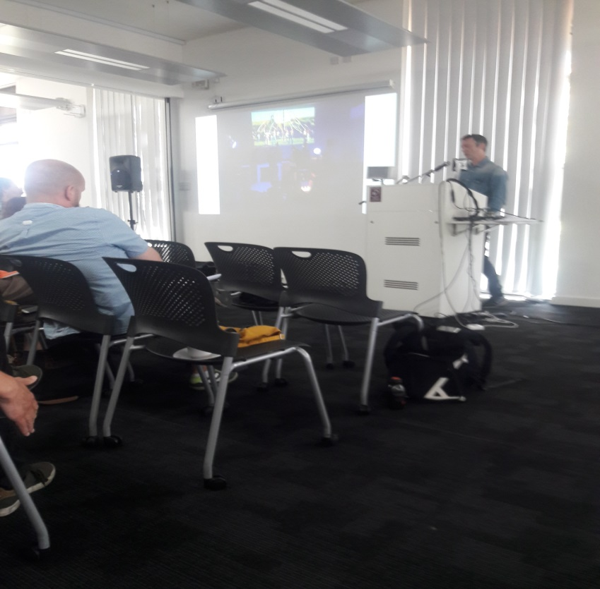
Simon O’Sullivan at the Bath Symposium
According to SOS there has been a huge growth in the arts that relate to fictioning, so much more prevalent than before. Could it be due to our ‘post truth’ ‘post fact’ times?
Listening to SOS talk about his work with Plastique Fantastique he comments on the idea of collaboration and how important this aspect of his practise is. You are presented with a diversity of perspectives and this can enable the group as a whole to evolve and develop. Later on in the day I asked him about this as I had visited a recent Plastique Fantastique show at IMT Gallery, London.
I said I really loved the show but I was pretty perplexed on what was happening. He said “When you are working with a group of fellow artists you are able to develop a language that is idiosyncratic to you. It can be quite hard for an outsider to decipher it”
SOS describes how in order to activate something in his work he finds feelings of shame a key trigger. It helps him develop a fiction of the self-producing something that is of you but not of you.
He uses science fiction as a resource and its reflection back on reality. The work of William Burroughs is also an important influence. Thinking about this a bit more closely, Burroughs appears frequently as an influence in music, film, art and of course literature, in particular his cut up technique or aleatory literary technique which he used in his Nova Trilogy of books. This technique was initially developed by the Dadaist movement and Tristan Tzara in the 1920’s and involved taking a written text and then cutting it up into separate lines and then jumbling all these lines up and pulling them randomly out of a hat to create a new text. By working this way you are introducing the element of chance into the act of creation thus creating a fiction that would otherwise not exist and is also not of you. David Bowie was also known for doing this in the 1970’s.
The author J G Ballard cited Burroughs as the most important author since the end of the Second World War. Ballard is another character who appears frequently and seems to influence this area of art and literature. SOS discussed the artist Robert Smithson and his relationship to Ballard. Smithson is probably most known for his land art sculpture Spiral Jetty which was created in 1970. His sculptures were heavily influenced by Science fiction and myth. One such book by Ballard, ‘The voices of time’ is cited as the direct influence to Spiral Jetty.
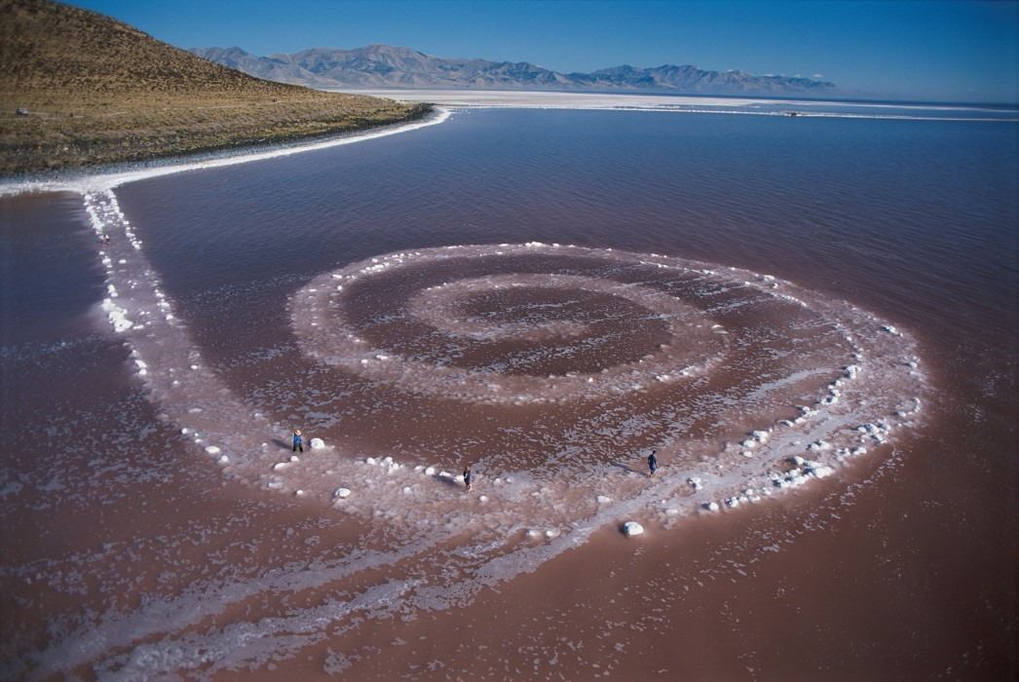
Spiral Jetty by Robert Smithson, 1970. Photo courtesy George Steinmetz
‘a cosmic countdown signals the approach of an eternity of sleep for humankind. The protagonist, Powers, after encountering a spiral structure meant to represent the square root of -1, surrenders to the flow of cosmic time within a spiral mandala, located on the salt lake of an abandoned air force testing range. Ballard’s use of the spiral as a symbol for cosmic time, from the scale of the sculpture to the magnitude of the galaxy, finds its expression in Smithson’s sculptures.’ (Ballardian, Andrew Frost March 13th, 2013)
In turn, Ballard said of Smithson to be one of the most influential post war artists. After seeing an article by the artist Tacita Dean in her attempt to locate the spiral jetty, Ballard wrote to Dean telling her of his equal fascination with Smithson and he also sent her a text he had written as an introduction to an exhibition about Smithson. He wrote “What cargo might have berthed at the spiral jetty. My guess is it was a clock, of a very special kind. In their way, all clocks are labyrinths and can be risky to enter”
This ‘fiction upon a fiction’ is something SOS talks about. The buzzword at the symposium was ‘A nesting of fictions’
I recently watched a documentary film about the 80’s post punk band Joy Division and their lead singer Ian Curtis who committed suicide fairly early in the bands life. Watching Joy Division perform and in particular watching Ian Curtis dance and contort himself on stage as if in some kind of shamanic trance was fascinating and it did make me think about the performances I have seen(only on You Tube) of Plastic Fantastique. Something about the trance-like states of the performers. Looking closer at this possible connection you discover Ian Curtis was a user of the cut up technique. One of the songs is titled Atrocity Exhibition. This title refers to a collection of experimental short stories by Ballard. Burroughs wrote a preface to this book, published in 1970.
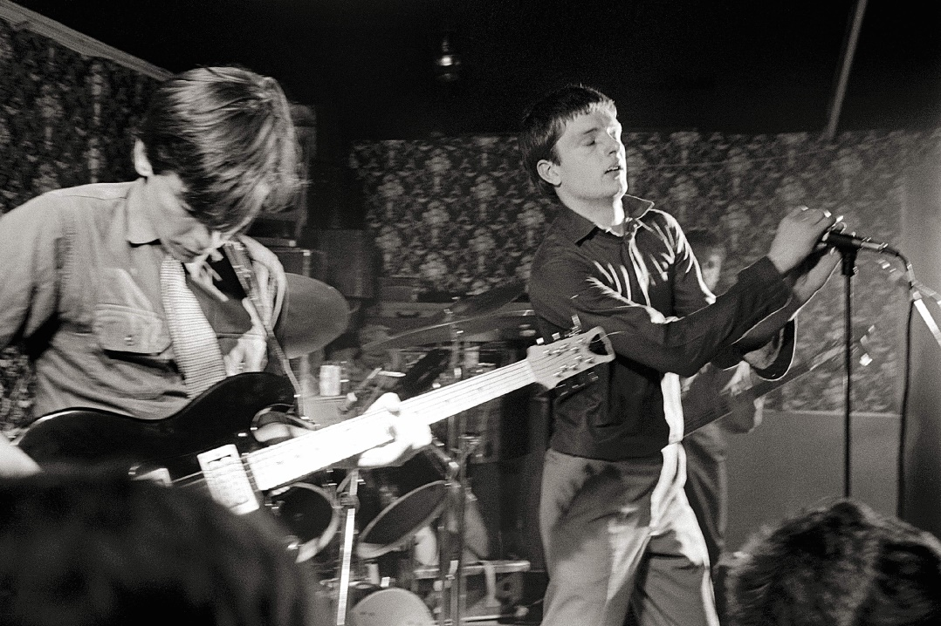
Joy Division 1979. Copyright Martin O’Neil, Redferns
Another devotee of the aleotoric method was the composer John Cage. Unlike the previous cut up method, Cage used the I Ching book, a book normally used for divination. To compose a piece of music, cage would come up with questions to ask the I Ching. The book would then be used in much the same way for divination. This became Cage’s preferred way of composing after 1951. Later on he would use a computer algorithm to do much the same thing.
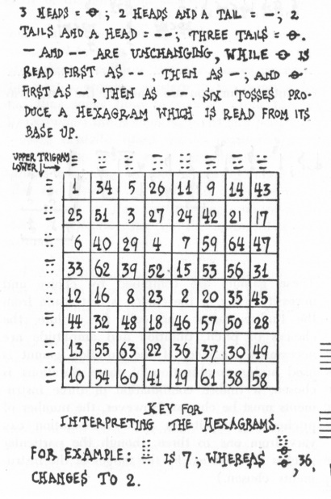
John Cage, Illustration “4 Musicians at work” Trans/formation. 1952. Courtesy of John Cage Trust
Hugely inspired by Cage among others was the musician and artist Brian Eno. Eno became known initially when in the band Roxy Music in the early 70’s. Fronted by Brian Ferry. Eno was a technical wizard and it was his use of synthesisers and sound manipulation that gave the early Roxy Music its distinctive sound. On stage Eno would look like more of a scientist than a musician or a Nasa engineer at a control panel covered with dials and knobs that he would be turning to generate the manipulated sounds. Eno’s more experimental approach to music clashed with Ferry’s more traditional style and he eventually left. Looking at Eno in those early Roxy Music days I am again reminded of the plastique fantastique performances where the members are sitting using laptops and sound machines during those performances. What would normally be considered something that is set to the side is brought to the main stage for the audience to view and interact with. The technical aspects of a performance are elevated to be equal with the visual.
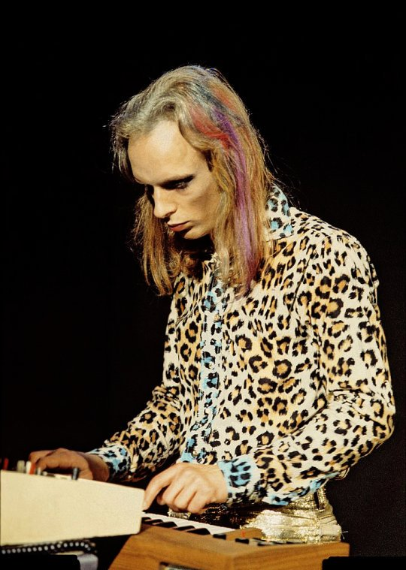
Brian Eno 1972. Image courtesy Brian Eno
PF’s most recent performance and exhibition were called Zer0City at the IMT Gallery in London. I had every intention of making the performance but the Central line was in chaos and I couldn’t get a train from Tottenham Court Road. I could’ve turned up late but as mentioned earlier I hate being late and I would absolutely not have wanted to walk in on a Plastique Fantastique performance mid-way through. I managed to see a couple of excerpts and photos on the galleries Instagram page.
When I did visit the gallery a week later I was the only person there apart from the gallery owner. I was given a piece of A4 paper and was left to wander around. On the piece of paper it was written
Invitation Contract for Zer0-City
0-Contract of TIMEmploymeme, which includes particulars pursuant to the TIMEmploymeme ACT (0000), is entered into at 00:00:00:00, between:
1 Zer0-City;and
2 You (the Meme-Tech-Animal)
To take up the invitation to enter into Zer0-City, IT IS HEREBY AGREED as follows:…’
The contract then lists your rights and obligations during your ‘time’ at Zer0-City.After standing in the entrance to the gallery and reading this I probably felt even more perplexed about what I was seeing. This was my first visit to the gallery and also to a Plastique Fantastique installation. After the gallery worker had left me I began to look around the main room. I put on a face of seriousness implying I knew what I was looking at. They had CCTV so for all I know they could have been laughing their socks of in the back room looking at another bemused gallery visitor. The room was filled with ten 2 metre x 1 metre large ply wood boards that were coated with giant digital prints showing strange people doing various things like hula hooping or flying in the sky with drones attached. Some of the boards had holes drilled through them and out of these holes were ropes that were adorned with feathers and light bulbs. I began to study these boards. The description in the A4 hand-out described them as Sigil and Meme-Animals. The definition of Sigil is an inscribed or painted symbol considered to have magical powers. The definition of meme is an element of a culture or system of behaviour passed from one individual to another by imitation or other non- genetic means.
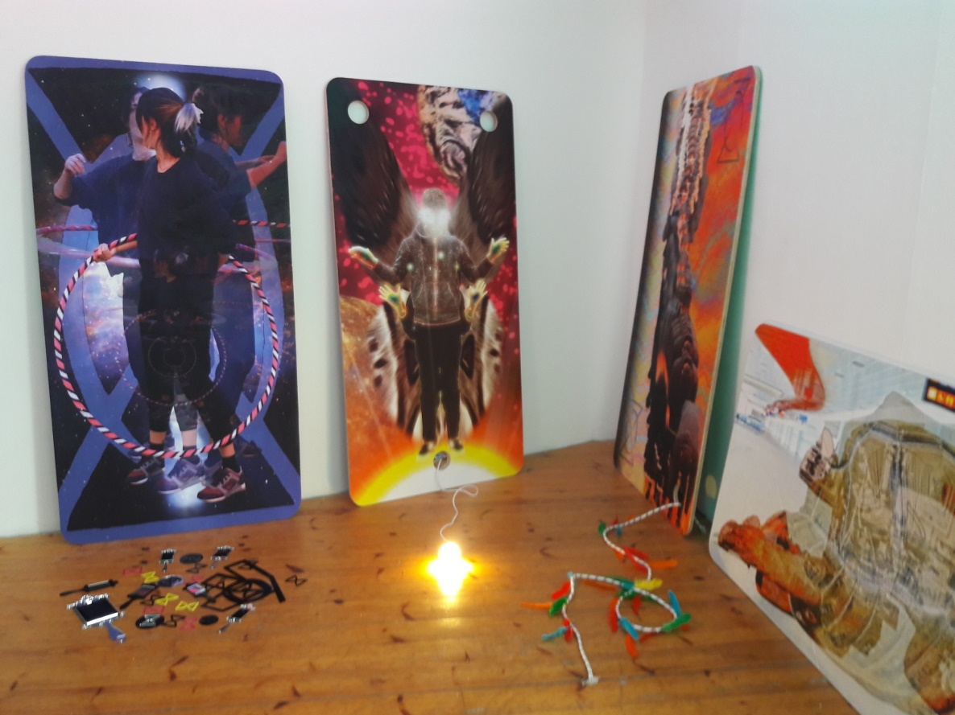
Installation view of Zer0-City, Plastique Fantastique at IMT Gallery. Image courtesy of the author
The relationship to Tarot Cards is what strikes you about these pieces. They are imbued with mystical meaning and powers. The curious holes with physical projections straggle across the gallery floor connecting each of the giant Sigil boards.
Just then, as if my nervous anxiety wasn’t enough, a weird looking hairless cat jumped out from behind the door and landed on top of me. I’d no idea where it came from. It jumped off me and landed on a sculpture that was in the middle of the room and then trotted off into the next room. I wondered if the gallery staffs were watching the CCTV. Slightly shaken I studied the sculpture more closely. It is titled DEE-VRIL-00. It is a table with a hole cut into it and a staff coated in ribbons protruding from it with some kind of mystical symbol attached to the top. I’ve never heard of the word vril so I look it up.
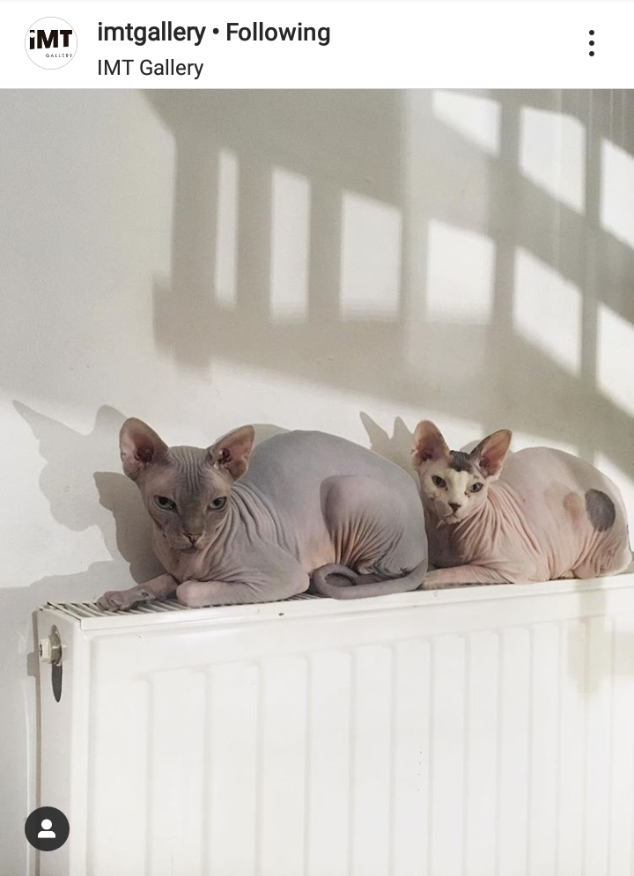
Hairless cats at IMT Gallery. Instagram post by IMT Gallery.
Vril is taken from a book called ‘The Coming Race’ published in 1870. In it a young man descends into the earth to discover a race of angelic like beings that populate a city similar in design to ancient Egyptian architecture. These beings are called Vril-ya and are gifted with telepathic and healing powers. The society is a technologically supported utopia and there main power comes from an all permeating liquid called ‘Vril’. If Vril-ya are trained correctly they can harness the power of this liquid. They can heal, change, destroy beings and also if powerful enough destroy entire cities.
A Vril staff is an object the shape of a wand or a staff that can channel Vril. Looking at the sculpture again in the middle of the room and also understanding what Vril is opens up this work into a much larger reading.
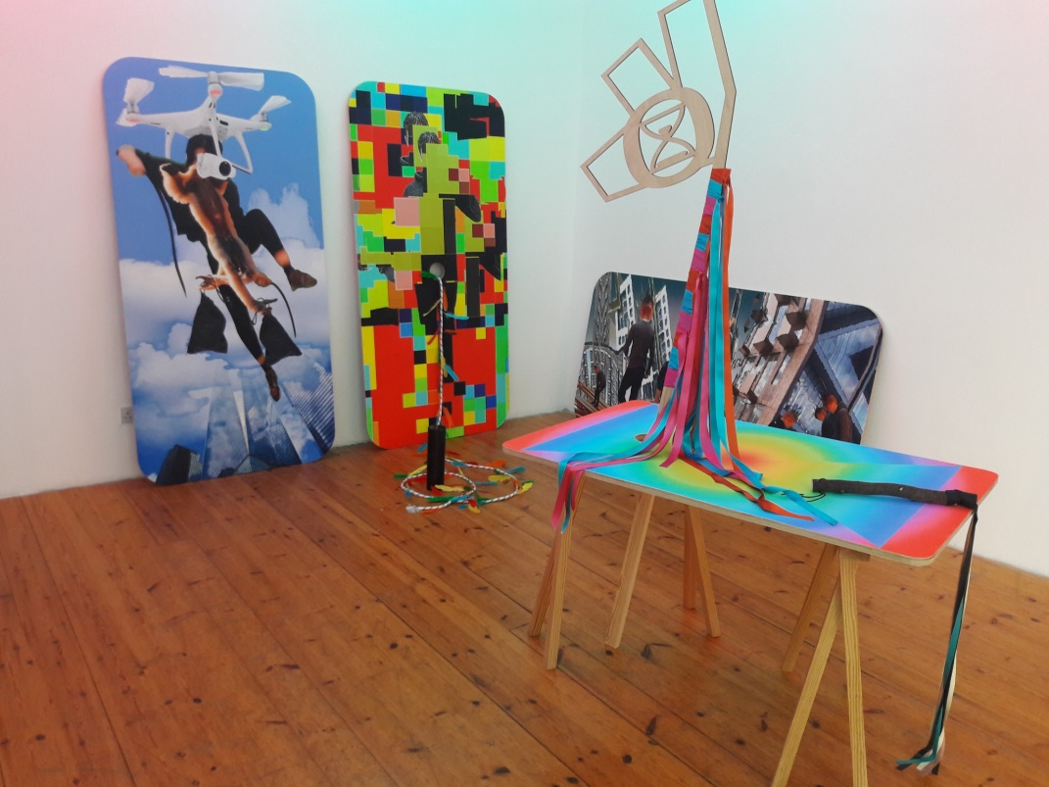
Installation view of Zer0-City at IMT Gallery with DEE-VRIL-00 sculpture in foreground. Image courtesy of the author.
Looking at this sculpture surrounded by the giant Sigals you begin to see the mythopoeic process. The creation and development of a new myth but layered over old. A fiction up a fiction.

Working as a collective enables the Plastique Fantastique to develop and expand their mythopoetic world in a shorter space of time. Works of science fiction fill a gap in our modern society that would have otherwise been filled by myths. Professor of Literature Joseph Campbell states that our Nietzschean world has outlived the myths of the past and such we must create new ones, but he believed present culture was developing too fast for us to be described by any present day myths until a much later age.
Knowing about ‘The Coming Race’ opens up a small window into this world I have up until now found slightly daunting and impenetrable. I want to talk to SOS about this more.
Time Codex 16.07.2019.16.15
I could talk about several of the other speakers as they all provided something insightful and useful. John Wild’s talk about psychogeography in the digitally expanded city was fascinating. Annoyingly he had to cut it short because the previous talker over ran. What’s more irritating is I don’t think many people knew what the previous speaker was talking about and I could see the panel leader’s frustration also. I’ve always been interested in psychcogeography. I’ve never identified it as a ‘thing’ but I will always take the opportunity if possible to walk or ‘meander’ in London, to explore and absorb the urban landscape. The definition of psyschogeography is an exploration of urban environments that emphasize playfulness and drifting. John talked about the arrival of 3G in his area and how he discovered a frequency anomaly directly over his sofa. The installation of 3G across the country was met with a lot of controversy. The majority of masts were to be put on top of tower blocks. Fears over health risks led many of these masts to be torn down. In one instance a group of Kurdish activists chained themselves to the mast that was to be installed on top of their block while it was still on the lorry.
‘In this febrile atmosphere of utopianism and paranoia, it was clear that the construction of wireless and mobile networks signalled a significant transformation of the landscape. I purchased an A-Com receiver used by telecoms engineers and started to listen to the new world of data transmissions. The crackle of white noise greeted me as I switched it on. I noticed a distant pulsing signal that drew me towards it. I was in the front room of my flat and its intensity increased as I started to approach my settee. The sound throbbed with metallic bass tones. I moved my receiver towards the settee then back again. The signal was surprisingly spatial. I carefully traced its shape revealing an invisible pulsating electromagnetic sphere hovering above my orange settee. From that moment, I saw the city as overlaid with invisible lines, shapes and structures, a coded geometry of machine to machine interactions beyond our perception.’ (http://www.codedgeometry.net/johnwild/in-search-of-the-digitally-expanded-city/)

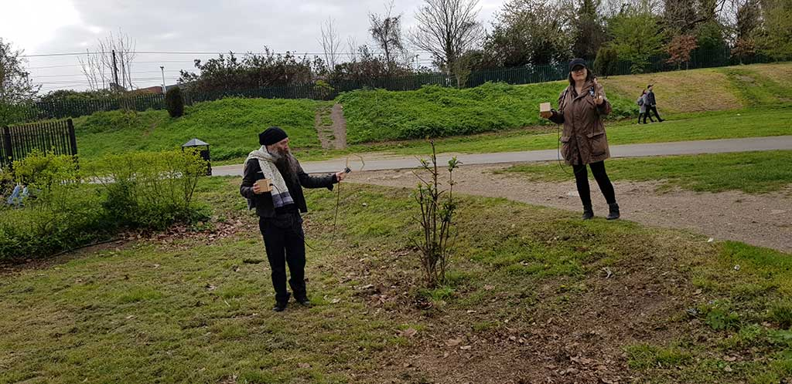
Robin and Nicky searching for invisible digital geographies using the A-Com receivers. Image courtesy of John Wild.

Another speaker I want to mention briefly was Teodora Sinzaina Fartan. She is currently studying an MFA in Computational Arts at Goldsmiths. She talked about her work and the use of a Markov Text Generator.
A Markov text generator is a computer program tool that is used to generate a new text from a text you feed it. It basically breaks down the text you supply and then reorders it but still in a coherent way. Having tested the generator with some of my own writings I think it is basically a digital version of the cut up system. The new texts it produces are of me, but not of me. It is that removal of the self to create a new text I find interesting. The text is a surreal fiction. It feels quite DADA so returns in a way to Tzara’s work of the 1920’s but with a new and informed direction.

Time Codex 16.07.2019.17.35
After a very intensive day of talks and panel discussions we are allowed near some wine to finish off the symposium. I manage to say hello to SOS for a few minutes. We get on really well and he is really touched I have been studying his writings and following the Plastique Fantastique performances. It was a shame that I didn’t know about Vril or Sigils when we spoke. It’s only this essay that has led me to investigate and try to understand more of what the Plastique Fantastique collective are exploring. And I know I have only scratched the surface of this research. If you look at Plastique Fantastique’s website it is filled with film, photo and comic work dating back many years.
Time Codex 16.07.2019.18.23
I leave the symposium and get on the U5 bus that will take me back to Bath centre. I think Dale jumped in an Uber with a few people to Bath as he was heading back to London on the bus that night. Once in Bath I popped into a local pub and ordered a pint. I took out my SOS articles and began reading again but this time with an added wisdom I hadn’t had eight hours previously. I begin also to formulate how I might now write this essay, or should I say re-write as I had already written 2500 words before I attended the symposium which I am now not happy with.
Time Codex 21.07.2019.12.23
Things I never got to:
Sun Ra-Archestra, Orphan Drift, Sonic Fictions, Ursula K Le Guin, David Burrows, VN5 Matrix, Etic Lab, Eco Scifi, teleology, Jeanette Thomas, Techno folkloric fable, Vocoder, Andy Weir, Marker project, Design fiction, Raising Ulla, Ridley Walker.
Please click on the link to see a film of the essay performed through a Markov chain text generator.
https://www.youtube.com/watch?v=6RWpMnADyxI&feature=youtu.be
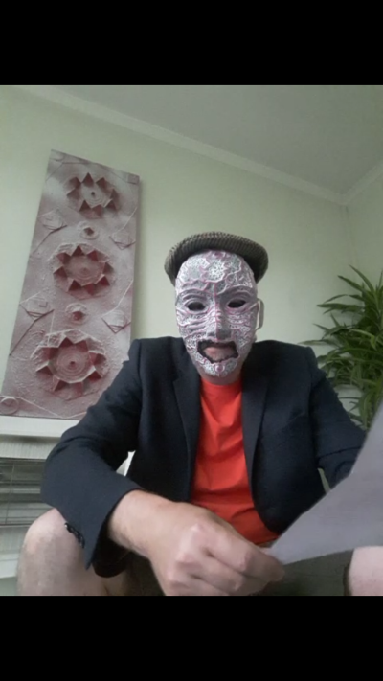
The author as Burnt Toast Geometry reading the above essay through a Markov Text Generator.

Fiction as Method (2017) edited by Jon K Shaw, Theo Reeves-Evison, Sternberg Press
Futures and Fictions (2017) edited by Henriette Gunkel, Ayesha Hameed, Simon O’Sullivan, Repeater Books
The Coming Race (1871). Edward Bulwer, Lord Lytton, Loki’s Press
Le Guin, U.K (1985) Always Coming Home, Gollancz 2016
O’Sullivan, Simon (2018) Fictioning the landscape. Journal of Aesthetics and Phenomenology, 5:1, 53-65, DOI: 10.1080/20539320.2018.1460114
From Science Fiction to science fictioning: SF’s Traction on the real, Simon O’Sullivan pp. 74-84, Foundation The International Review of Science Fiction, no.128(2017)
http://www.codedgeometry.net/johnwild/in-search-of-the-digitally-expanded-city/

