The Court of Redonda. A fictional Truth
It’s 5.15 am and my Only Fools and Horses alarm clock has just switched on and is singing about putting a pony in my pocket while I fetch a suitcase from the van.
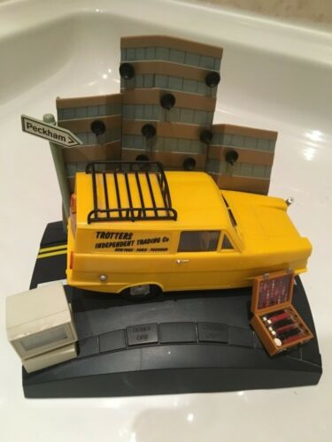
I read recently that Nelson Mandela House was due to be demolished. This was the tower block featured in the classic British television Show Only Fools and Horses. Of course it’s not called Nelson Mandela house in real life although I’m sure the residents affectionately refer to it as such.
It is in fact called Harlech Tower and it resides in Ealing and not Peckham where the classic sitcom was set. This is one example of a fictional truth and it is one of the things that interests me with regards to The Kingdom of Redonda.
My train leaves at 6.30 and I am heading to Hackney to meet Stephen Chambers at his studio. It’s a fairly long journey hence my early start.
I’ve always been a huge admirer of Stephen’s paintings and prints after seeing a show at Flowers Gallery many years ago. The show’s title was ‘This Man is a leopard’.
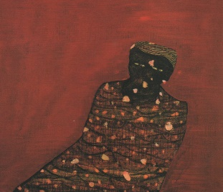
This man is a leopard. 1994 Stephen Chambers
Chambers most recent project is called ‘The Court of Redonda’ and consists of over 100 paintings of people that belong to this so named court. They are all of a similar size approximately 38x49cm and are all oil on panel. Each painting has its own enigmatic title. ‘Philip the truthful liar’, ‘Duke of Vapour’, ‘Magda, la Encantanda, ‘Harold the bum’ to name but few. This court is a Fictional creation and has its origins from the Spanish writer Javier Marias.
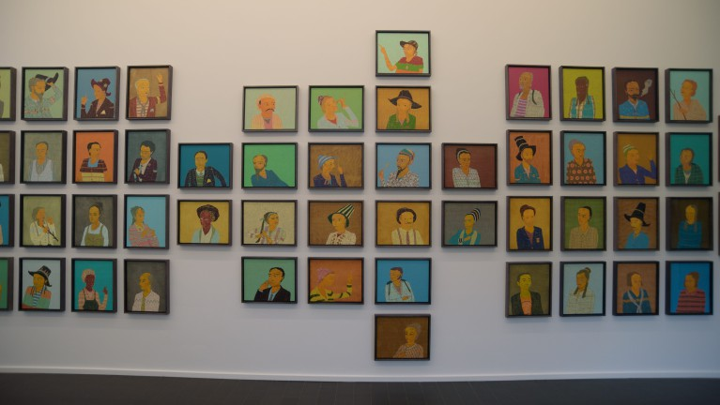
The Court of Redonda. © Jean-Luc Benezat / Stephen Chambers Studio
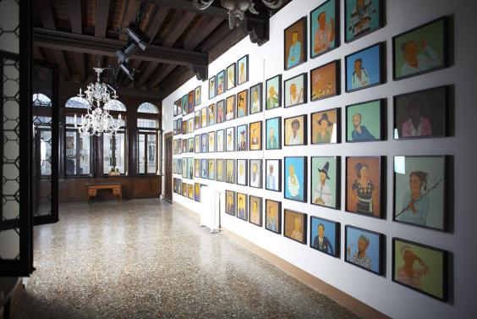
The Court of Redonda at The Venice Biennale
Courtesy of Stephen Chambers Studio
Stephen came across Marias writing in a book called ‘All Souls’. This book is a fictional account of a Spanish teacher and translator living and working at Oxford University in the late 80’s. In this book there is a reference to the Kingdom of Redonda when Marias discusses an author called John Gawsworth (1989, p.102). I think very few people have heard of the Kingdom of Redonda and also John Gawsworth.
Redonda is a small island about one mile long by approximately half a mile wide. Nothing lives on the island except boobies and rats. It was named by Christiforo Columbo in 1493. Other than being briefly home to guano miners it has never been inhabited.
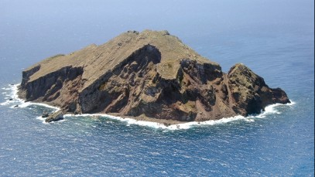
Redonda. Image courtesy Antigua marine guide
In 1865 a trader called Matthew Dowdy Sheil reclaimed the island from the Spanish and declared himself King Of Redonda. In 1880 Sheil passed on the kingdom to his son MP Sheil at age 15. MP Sheil was later to become a science fiction author. From there MP Sheil passed on the kingdom to the writer John Gawsworth. The idea was to pass on the kingdom to writers and artists. Gawsworth was never able to take possession of his kingdom as the British annexed it due to the discovery of aluminium sulphate. In spite of this Gawsworth would sign some of his writings as Juan 1st, King of Redonda. Gawsworth bestowed dukedoms to several writers he admired including Dylan Thomas and Henry Miller.
He is also said to have passed down his kingdom to several different people and this is where it gets confusing with various claimants to the throne. Gawsworth was known to be an alcoholic and lived his last years between Italy and London. He was often seen sleeping on a park bench.
John Wynn Tyson is one such person who claims Gawsworth passed his kingdom down to him.
Tyson visited Redonda in 1979. He ruled as King Juan 2 until abdicating in favour of the novelist Javier Marias in 1997. Marias or King Xavier as he is known was to appoint many artists and writers to his court. One such artist was Stephen Chambers and his title is Viscount Hue and Dye.
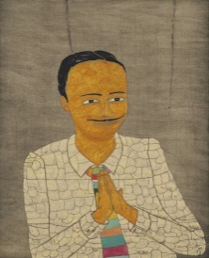
Marques del Mercado. Courtesy Stephen Chambers studio

Going back to All Souls by Marias, as he states it is a work of fiction but upon its release it was circulated around the Oxford campuses and became accepted as a piece of autobiographical work by members of staff and acquaintances that Marias had met or worked with. Many claiming to be the person referred to in the book. Some were happy to take on these personas and some were not so happy to even though Marias always states that they were not cameos.
In his book Dark back of Time, Marias comments on this situation with regards to a couple who ran a bookshop in Oxford. The couple who ran the bookshop featured in All Souls were not based upon this real couple but they seem to have decided that Marias did in fact use them as inspiration. This couple believed it so much that they bought several copies of All Souls to sell in their shop, even though they were in fact an antique bookshop. In Dark back of Time Marias recounts visiting the bookshop.
“Dear god,” I thought, “the Stones think assume they are the Alabasters, (1998,p.109) therefore they think it’s funny to sell in their store a novel that, according to them, speaks of them and of their store, in which they are now selling this novel that speaks of them. But the Alabasters would never have been able to sell my book, which creates and contains them”
To take it even further a film was to be made of All Souls and the Stones were keen to be involved.
‘It was hard to believe. (1998, p.109) The Stones not only assumed themselves to be the model of the Alabasters, but wanted to incarnate them, lend them their presence and their physiques if the fictional characters emerged from the book and acquired corporeality and physiognomies in a film; a strange round trip it would have been had their belief and their appropriation or identification been correct, which it was not. And if such an incarnation were to occur, then the fictional Alabasters would become in turn , a model for the real Stones, who would study and imitate them, though only while they played the Alabasters before a camera, or who knows if the thing might have gone even further’
I arrive at Stephen’s studio for 9am as promised. I bring coffee which I bought from a Danish cashless coffee shop round the corner. Not long after, Stephen’s studio assistant and secretary arrive and we sit and drink coffee and eat croissants. I gaze around the studio. Paintings leaning up against the wall, prints scattered around and a portrait in progress on the easel.
I ask if he has finished the Court of Redonda or is it an ongoing project. He tells me it is a completed work now. He had been made offers to sell parts of it but he wants it to be sold as one completed artwork.
Originally it was designed to be displayed in the loose form of a rock much like the shape of Redonda. This freer way of display has echoes with the large scale screen print installation the Big Country which was exhibited at The RA in 2012.
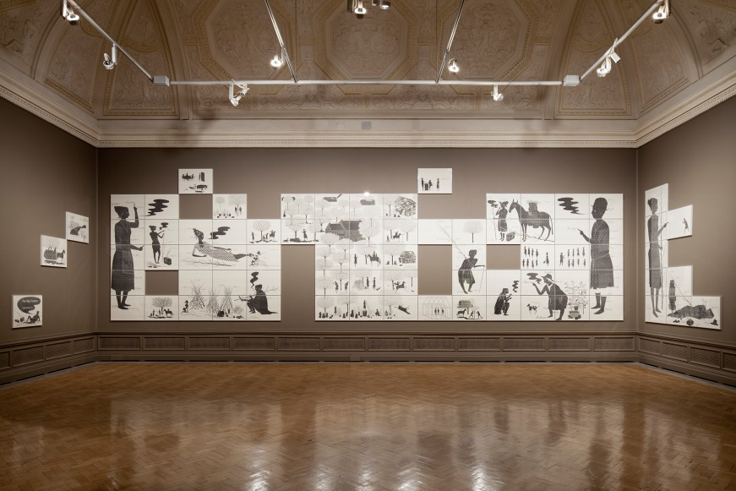
The Big Country. Installation view RA 2012. Courtesy Stephen Chambers Studio
I wanted to know whether Javier Marias had given Stephen the list of titles of the court but he says they are all his own creation. By doing this he takes the Kingdom of Redonda and expands on its own fictional legend. Much like the Stones and Alabasters, there may now people waiting in the wings that may approach Stephen and ask if ‘Johannis, the patient’ for example was based on them. The reply would most probably be no but it would not stop people believing the opposite.
The gestation of The Court of Redonda could be around 2014 when Stephen was working In Brooklyn. He was working on a sequence of prints relating to the Gangs of New York and the violent turf was that existed in the 19th Century. In 2005 Martin Scorsese’s film of the same name was released. It centres on an area known as Five Points where gangs will fight for territory. Now it is a busy road junction with no memory of its violent past. There is a junction of a similar name in South London on The Purley Way. What struck me about the film was its timelessness. Obviously it was pre America but it also could have been a post apocalyptic America. I imagine the Five Ways in Purley as a violent gang controlled area 100 years in the future. In Will Self’s Scale the motorways are all overgrown and individual gangs control different parts of the road. It is interesting how a space can occupy so many different experiences throughout its years. The Clock tower in The Back to the Future films can be seen as a fictional example of this.
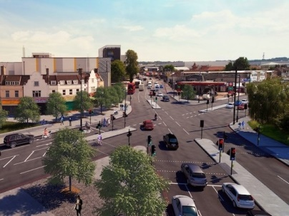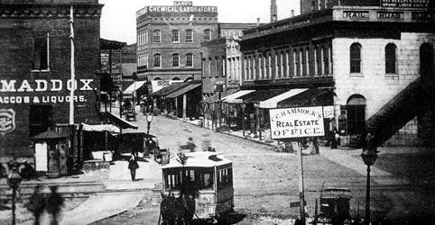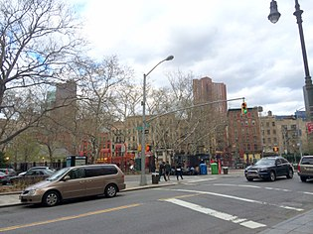
Five Ways Purley and Five Points Manhattan then and now
The people that populate Stephens Court are not aristocracy. They are you and me.
“I’m trying to elevate the ordinary. My understanding of the Court of Redonda is that it’s bringing to the High table those that would normally be fed in the garden shed”(2018,p.17)
Returning to tower blocks, in Marcus Coates work of 2005 ‘Journey to The Lowerworld’, we are transported to Rose’s flat on the 9th floor. In this room Marcus performs a shamanistic ritual in front of an audience of local residents, people who could easily live in Stephen Chambers Court. This artwork is a performance piece which does question the boundaries of fiction and reality. The film involves Marcus enacting a Yukil shamanic ceremony in order to contact the animal spirt world. With him he takes a question given to him by the local residents. The tower block is due to be demolished and the residents rehomed. They ask “Do we have a protector for this site?” and “What is it?” In the shamanic ritual you are only supposed to take one question with you so there is a secret panic from Marcus about having two questions. He had recently been on a shamanic Weekend course ‘Introducing participants to core-shamanism’. He found it successful and was able to descend into the lower world using the cartoon Jamie and The magic torch as a focus for opening up a portal. Once in the lower world you were not to seek out an animal spirit but that they should come to you. You were to ask your question or have it in mind.
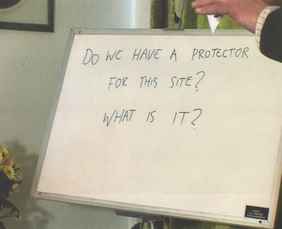
Journey to the Lowerworld by Marcus Coates. Image courtesy Nick David
Back to Rose’s flat and the audience was settling in and making jokes. Marcus explained the ritual was Siberian Yakut. He wore a stag head and used car keys attached to his shoes for bells and replaced the broom for a hoover. He then sat quietly and eventually entered the lower world. Over the next fifteen minutes Marcus produced a series of bird calls and guttural noises much to the horror and delight of the elderly residents of Sheil Tower.
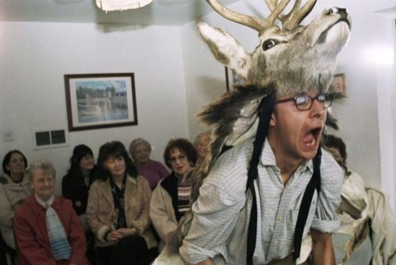
Journey to the Lowerworld by Marcus Coates. Image courtesy Nick David
“And then this moorhen came up-this smaller wader bird- this moorhen came up and I talked to it for a bit in its own language and it wasn’t very helpful, it kept shrugging me off. And then I went and talked to a coot and that didn’t want to know as well..”(2005)
I guess the question is how much of this performance is fiction and how much is truth or belief. For me there isn’t any question of him trying to mock the residents of Sheil tower. Is there a sense that by performing the ritual as fact it does become fact? I’m thinking now of the artist Rod Dickinson whose studio I visited in the 1990 s whilst on an undergraduate course. Rod told us he was responsible for most of the amazing crop circles that were coming out of Wiltshire at that time. There was no one to dispute this except people or groups that wanted to believe it was in fact carried out by aliens. Another of his works was to create false UFO photographs. He would then send these photos in to UFO magazines who would then publish these photographs as ‘genuine’ UFO pictures. Once the magazine had published them Rod would then only refer to them as genuine also.
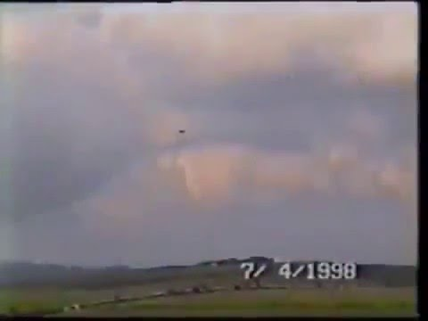
Still from video shot by Rod Dickinson showing a ‘UFO’ 1998
Javier Marias book All Souls was fiction but it was assumed to be fact. He then wrote a follow up nonfiction book defending the original books fictional criteria.
“I believe I’ve still never mistaken fiction for reality, though I have mixed them together more than once, as everyone does not only novelists or writers but everyone who has recounted anything since the time we know began…” (1998,p.7)
It’s time to leave Stephen and his studio assistant in peace as they continue work on a large painting entitled ‘Albion’
As I head to the station I think about The Court of Redonda and also the Only Fools and Horses alarm clock I nearly once bought.
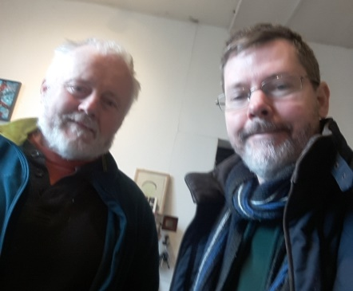
Image copyright Adam Green
Bibliography
Books
Abbot, E.A (1884) Flatland, Penguin Books
Chambers, S (2018) The Court of Redonda, The Heong Gallery at Downing College
Chambers, S (1995) This man is a leopard, Flowers East
Chambers, S (2012) Artists Laboratory, The Royal Academy of Arts
Chambers, S (2008) Stephen Chambers, Andrew Lambirth, Unicorn Press
Coates, M (2005) Journey to the Lower World, published in the Bookscapes series by morning star and platform projects
Fiction as Method (2017) edited by Jon K Shaw, Theo Reeves-Evison, Sternberg Press
Futures and Fictions (2017) edited by Henriette Gunkel, Ayesha Hameed, Simon O’Sullivan, Repeater Books
Le Guin, U.K (1985) Always Coming Home, Gollancz 2016
Marias, J (1998) Dark Back of time, Chatto and Windus 2003
Marias, J (1989) All Souls, Harvill 1992
Shovelin, J (2007) A Dream Deferred, Haunch of Venison
Shovelin, J (2006) Lustfaust, A folk Anthology 1976-81, Riflemaker Press
Articles
Marias, J (2006) Javier Marias, The art of Fiction No 190, Sarah Fay, The Paris Review
O’Sullivan, Simon (2018) Fictioning the landscape. Journal of Aesthetics and Phenomenology, 5:1, 53-65, DOI: 10.1080/20539320.2018.1460114
Films
Coates, M (2005) Journey to the Lower World
Marker, C (1962) La Jetee
Shovelin, J (2013) Hiker Meat
Shovelin J (2015) Rough Cut
Tarkovsky, A (1979) The Stalker

